County and District Council Report for March 2024 from Kathy and Tom Wells

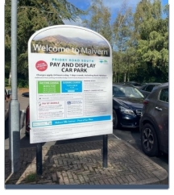
Proposed changes to car park times and charges
Malvern Hills District Council are proposing to make changes to car park times and charges - the first change, for most of these tariffs, in 12 years.
As part of a public consultation, there a number of changes to car parks which include stay-time increases, as well as a cost increase for some.
Amongst the suggestions, is one which has been asked for by traders - to increase the maximum waiting period from two to three hours in Malvern town centre car parks at Belle Vue Terrace, Edith Walk, Grange Road North and South.
As well as this, there is proposed, an increase to three hours for vehicles displaying a valid disabled person’s blue badge across all sites.
Other changes could include a cost increase of a 24-hour stay in a car park from £3 to £4 at the Council House, Victoria Road, Hanley Road, New Street, Priory Road North, Priory Road South, and Teme Street car parks.
Also, an increase in the cost of the evening tariff (4pm to 8am) from £1.50 to £2 at all car parks and an increase in the cost of the Resident Annual Two Hour Permits from £25 to £30 per year.
MHDC will continue to freeze the costs of the most popular tickets - the 50p one hour and £1 two-hour tickets. These will remain some of the lowest parking rates charged in the county.
For full details of the proposed changes and to have a say, please visit MHDC’s Consultation Webpage.
Any comments should be made before the deadline at 12pm on 28 March 2024.

Free property and home security events come to the district
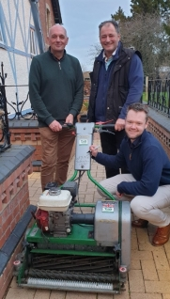
Property and Home Security events are being held by MHDC’s Community Safety Team. The drop-in events offer advice on a wide range of preventative security measures to reduce the likelihood of being a victim of theft or burglary.
Officers are on hand to discuss any crime prevention questions and offer advice on how to maximise the chances of having stolen property rightfully returned.
The next free drop-in session will be held on: Thursday, 21 March, at Hanley Swan Village Hall, from 5pm - 7pm.
Look out for more planned events from April onwards.
Visit www.malvernhills.gov.uk/community-safety for more information about these events.
The team recently visited Tenbury where they marked property from residents, including Tenbury Town Council.

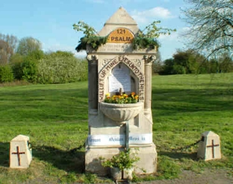
This Year’s Well Dressing Theme
The theme for the Malvern Water and Well Dressing Festival 2024 will be … Trees!
The popular festival, which will be held from 4th to 12th May 2024, will see many wells, springs and spouts creatively decorated by local residents, organisations and businesses.
The annual event is organised by Malvern Spa Association and celebrates the history of the Malvern Hills, from its iconic spring water and Victorian Water Cure to the area’s ancient Pagan traditions.
Visit www.visitthemalverns.org/blog/malvern-well-dressing-festival-returns/ to find out more.

